**Lesson Notes**

1. What is the main purpose of an Operating System?
2. Simpler / More Efficient Application Programs
3. Consistent User Experience
4. Allow Multiple Applications Running at Same Time
5. What is the difference between Operating System Software and Use Application Software?

Hardware Independence

* + Same applications can run on different computer hardware
  + Operating System must be configured according to hardware components present in the computer

User Interface

* + Applications focus on what is contained and displayed within a window
  + Operating System controls opening / closing / resizing windows and responding to mouse and keyboard actions
  + Operating System provides standard ways to print, save and open files, access the internet, etc.

Resource Allocation

* + Applications just ask for what they need (e.g. Memory, Disk Space)
  + Operating System checks for availability and access permission
  + Operating System coordinates resource allocation between applications

1. What is the difference between Operating System Software and Computer Hardware?

* Graphical User Interface (GUI)
* System Calls
* Device Drivers
* I/O Manager

1. What are the main parts of an Operating System?

* Memory Manager
* Process Manager
* Security Monitor
* Update Manager

1. What are some popular operating systems?

* Windows OS
  + PCs / Laptops / Tablets
  + Mac OS
  + PCs / Laptops
  + Linux / Unix
  + PCs / Laptops / Phones / Embedded Devices
  + Android / Chrome
  + Phones / Tablets / Embedded Devices
* iOS
  + Phones / Tablets
* z/OS
  + IBM Mainframe Computers

**Reference Diagram**

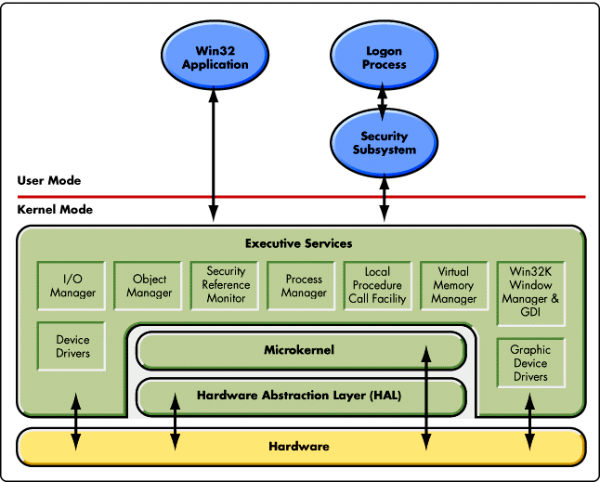

**Student Questions**

1. What is a device driver?
   1. Provide a brief summary
   2. List some devices that require a device driver.
   3. Provide a label on the reference diagram for the location of a device driver for your graphics card.
   4. Provide a label on the reference diagram for the location of a device driver for a locally attached printer.
2. A device driver is a software program that controls a specific type of hardware device that is attached to a computer, device driver essentially allows smooth communication between a connected hardware device and the operating system
3. device driver to connect to a computer include printers, displays, CD-ROM readers, network or sound cards, computer mice or hard disks

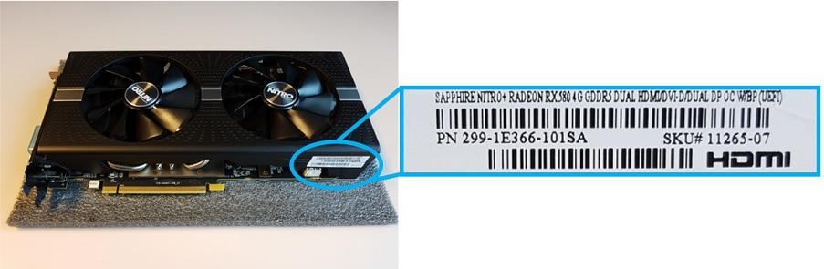

1. 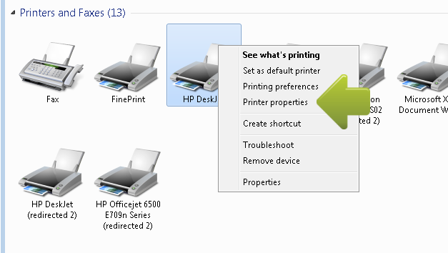
2. What is a DLL?
   1. Provide a brief summary

For the Microsoft Windows operating systems that are listed in the "Applies to" section, much of the functionality of the operating system is provided by dynamic link libraries (DLL).

* 1. Explain how DLLs are related to user application programs

Software & Games runs on the bases of DLL Files; DLL files was created so that multiple applications could use their information at the same time

* 1. Provide a label on the reference diagram for the location of a DLL

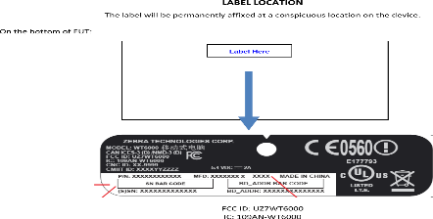

1. What is a windows manager?
   1. Provide a brief summary

The job of a window manager is to handle how all of the windows created by various applications that share the screen and who gets user input at any given time

* 1. Explain how a windows manager is related to user application programs

Operating system (OS), program that manages a computer's resources, especially the allocation of those resources among other programs. Typical resources include the central processing unit (CPU), computer memory, and others.

* 1. Provide a label on the reference diagram for the location of a DLL

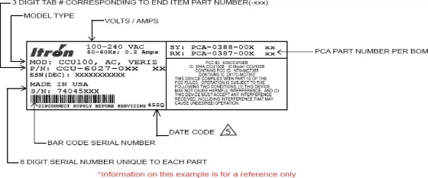

1. What is the windows task manager?
   1. Provide a brief summary

Windows Task Manager enables you to monitor the applications, processes, and services currently running on your PC. You can use Task Manager to start and stop programs and to stop processes, but in addition Task Manager will show you informative statistics about your computer's performance and about your network.

* 1. List and explain four (4) types of system information provided by the task manager

While the Task Manager is open, you'll see a Task Manager icon in your notification area. This shows you how much CPU (central processing unit) resources are currently in use on your system, and you can mouse over it to see memory, disk, and network usage. It's an easy way to keep tabs on your computer's CPU usage.

* 1. Provide a label on the reference diagram for the operating system components related to each type of information.

